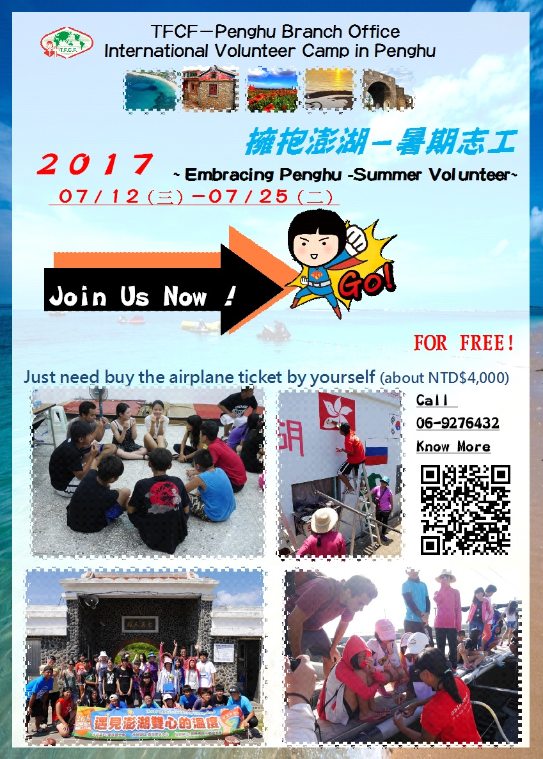
2017 International Volunteer Camp in Penghu
- Background:
Penghu is the largest island archipelago of Taiwan. Featuring its azure sea and bright sunshine, Penghu consists of 97 islands and islets, and the nearest one is only about 50 km away from Taiwan. TFCF Penghu was established in 1965, and the main focus is to support children whose family encountered accidents or having economic hardship currently.

Date:12 July 2017(Wed.) – 25 July 2017 (Tue.)
- Program objectives and objectives:
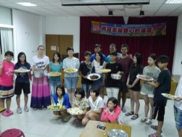
- Recruiting 10 international volunteers who are interested in Taiwanese culture and are willing to serve in distant islands .There will be 10 foreign volunteers and 2 Taiwanese Volunteer working as deputy coordinator of the whole program.
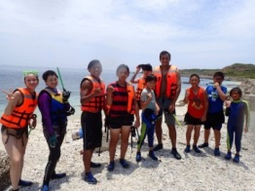
- Developing the children’s and international volunteers’ abilities of planning activities and team spirit through the pre-camp training courses
- Promoting the understanding of both local and foreign cultures through the two-weeks team activities.
- The program schedule:
- 2017.05-06 Recruitment -Local Youth Volunteers and International Volunteer.
- Recruitment: Before 2017.06.10 (Registration is limited.)
- Implementation– Camp STARTS : 2017.07. 12(三)come phenghu-2017.07.25(二)go back .
- The Location of implementation:
TFCF Penghu Branch Office、Penghu Island、remote islands of Chimei and Wangan.
- Budget:
1. The program is financed by the TFCF, which covers all activities during the camp preparation and during the implementation and inciude eating.
2. However, volunteers have to pay (1) the round-trip transportation cost between Penghu and Taiwan and (2) any personal expenses in the free time of 7/18-7/19.
IF YOU WANT TO JOIN US !
Call 06-9276432 & GO SENT YOUR Application Form TO US NOW.

Taiwan Fund for Children and Families Penghu Office(TFCF-PH)
International Youth Exchange Program-International Work Camp
Application Form
~Hugging Penghu’s blue skies, bright sunshine & teens~
Basic information（skip if no）
Refer to your passport and enter all information in the same format.
Chinese name |  |  |  |  |  |  | Name |  | （as passport） |  |  |  | （photo）
Date of Birth |  |  |  | （Y/M/D） |  |  | ID
Passport Number |  |  |  |  |  |  | Issuing Country*
Gender |  |  |  | □male  □female |  |  | Blood type
Cellphone Number |  |  |  |  |  |  | E-mail Address
ID of school |  |  |  |  |  |  | Department and grade |  | 系 年級
Resident Address |  |  |  | □□□□□
Mailing address |  |  |  | □□□□□
Emegercy （two person, foreign people please write one Taiwanese people）
Name |  |  |  |  | Relation |  |  | ages |  |  |  | phone
Resident Address |  |  | □□□□□
name |  |  |  |  | relation |  |  | ages |  |  |  | phone
Resident Address |  |  | □□□□□
Body situation （be honest, please）
totally：□healthy □nice □ok |  |  |  |  |  |  |  |  |  | asthma：□yes □no
Seasick, airsick：□yea( which ) □no |  |  |  |  |  |  |  |  |  | food：□all □ vegetarian
allergy：□yes（□medicines：（ which ）；□food：（ which ）
□no
illness：□cardiopathy □hypertension □diabetes □others（ what? ）
□no
Other important things：
the educational (or academic) background
（since high school, include studying abroad,）
Clubs, volunteer experience
(Employment, Nature of Job, service object and date (from – to) should be included: Also could provide NPO, NGO, activity certification, result or website)
Language proficiency
(Describe your listening/speaking/reading/writing abilities in different languages. Could provide related certification.
Native language： |  |  |  |  |  |  |  |  |  | Chinese：
English： |  |  |  |  |  |  |  |  |  | Others：
Other skills
Computer skills：□Micro Office □Hardware maintenance □Web design
□Programming□
Software ：
Multimedia：□ photography □ film □ video clips □ animation□
Software ：
Talent/skills ：□Host □ Drama □Group Leadership □Planning □Art Compilation □ Publicity □ Written Cooking □Planting □Music
Others：
Self-Introduction
Briefly talk about your Interests, habits and personalities
Motivation, Purpose and Pxpectation
1. Why do you want to be an international volunteer?
2. Which part of the service plan attracts you?
3. Do you think the international volunteer should have what conditions?
4. What do you think international volunteers may encounter?
5. What kind of experience or study do you expect from this event?
*Please send the registration form and the supporting documents to the International Trafficking Team, Penghu Family Support Center
Zhuang Yu Ting：yuting@ccf.org.tw
Liao Peien worker：swinnie@ccf.org.tw
Zhang Liyan： x91234@ccf.org.tw

